User Manual for a stock picker

In the home screen click on the stock button.

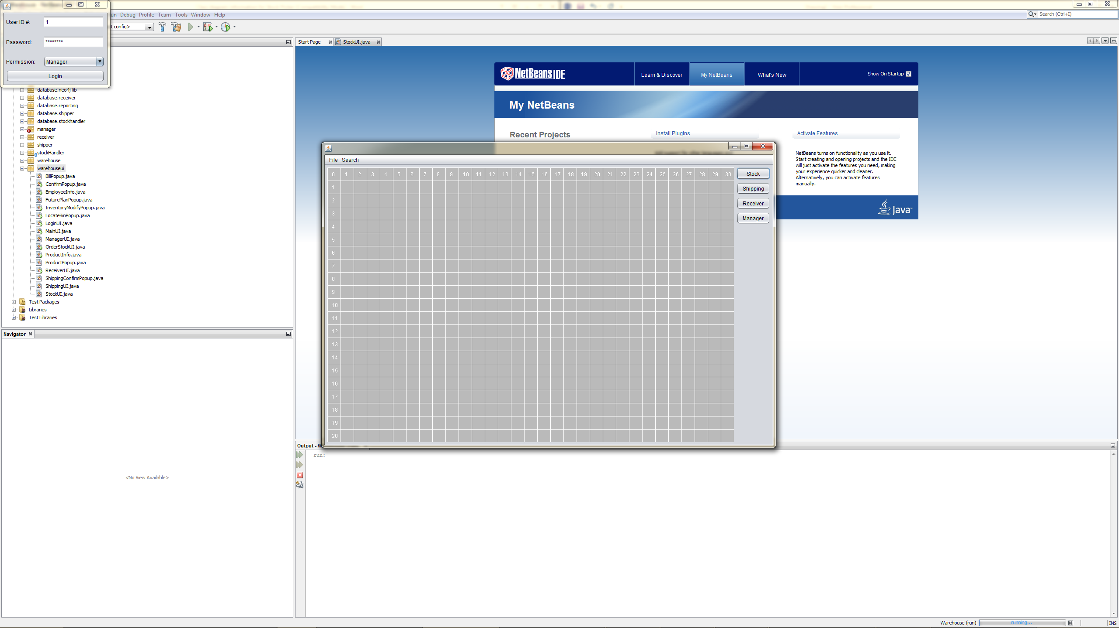

Next select the order you wish to fill. Select the combo box by clicking on it.

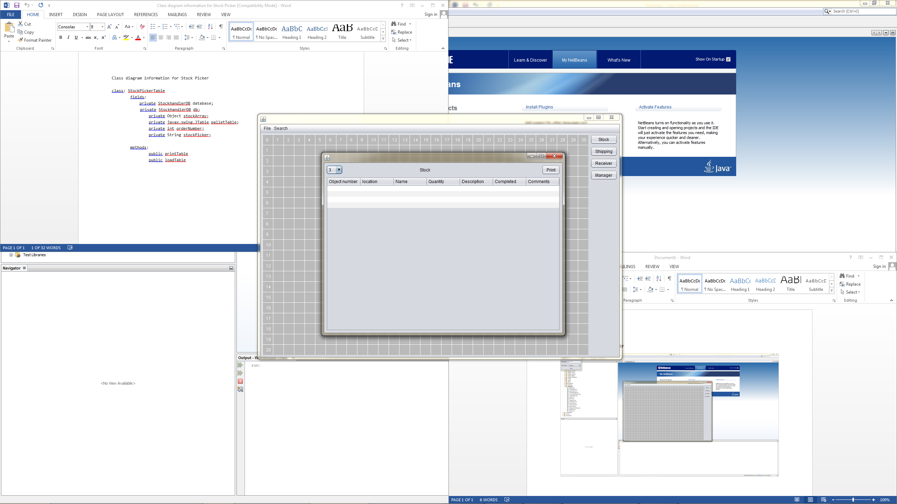

Now select the order you wish to be displayed in sorted, order 5 is currently selected.

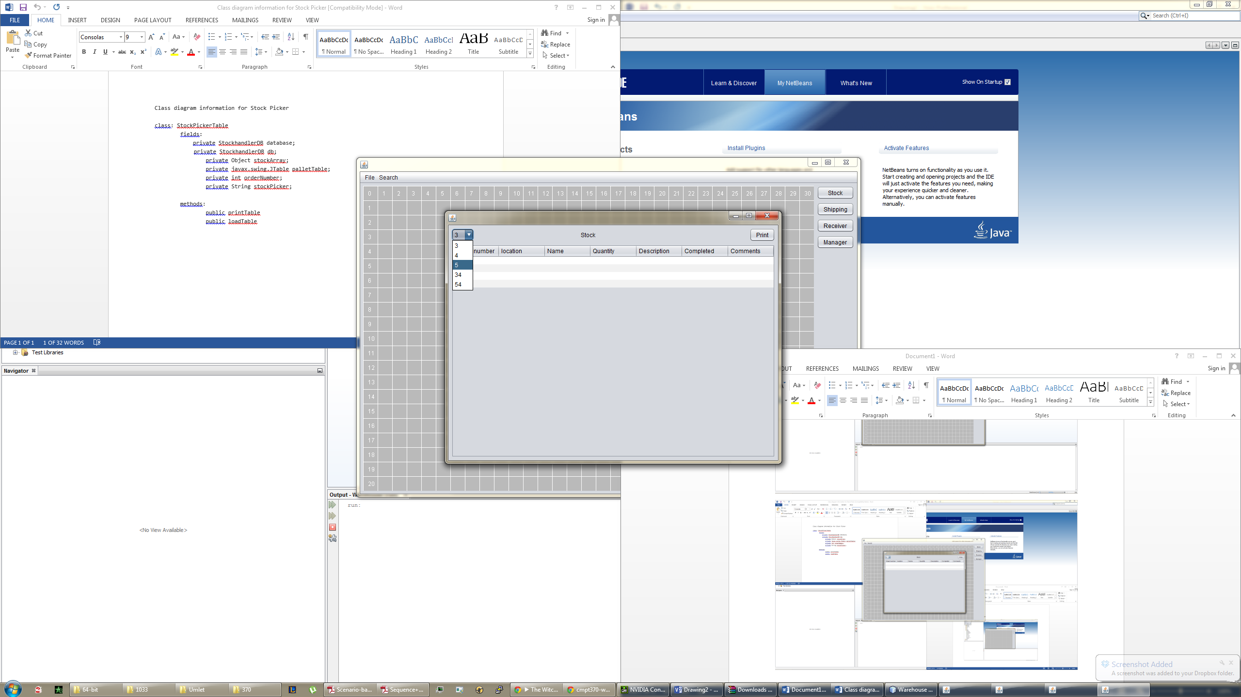

Now the table will be populated with your order. Select print to print the document.

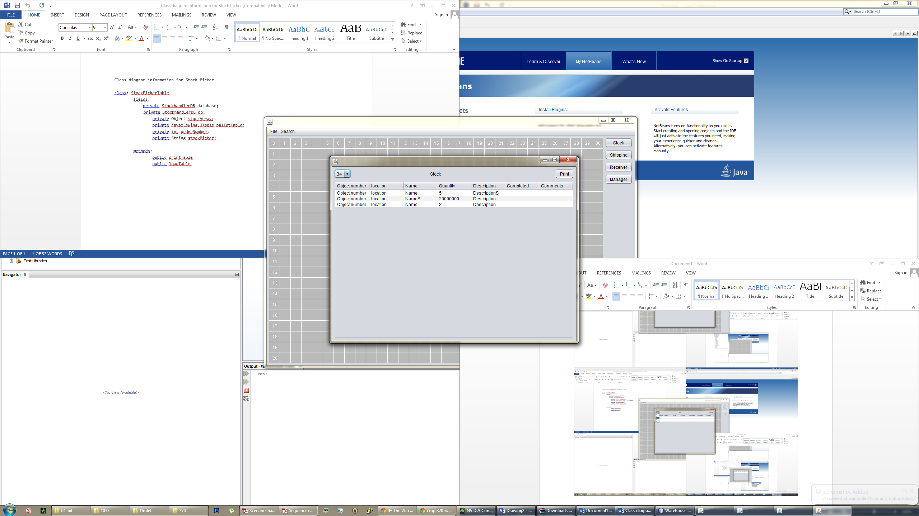

Chose your printing options or simple click print to print the document.

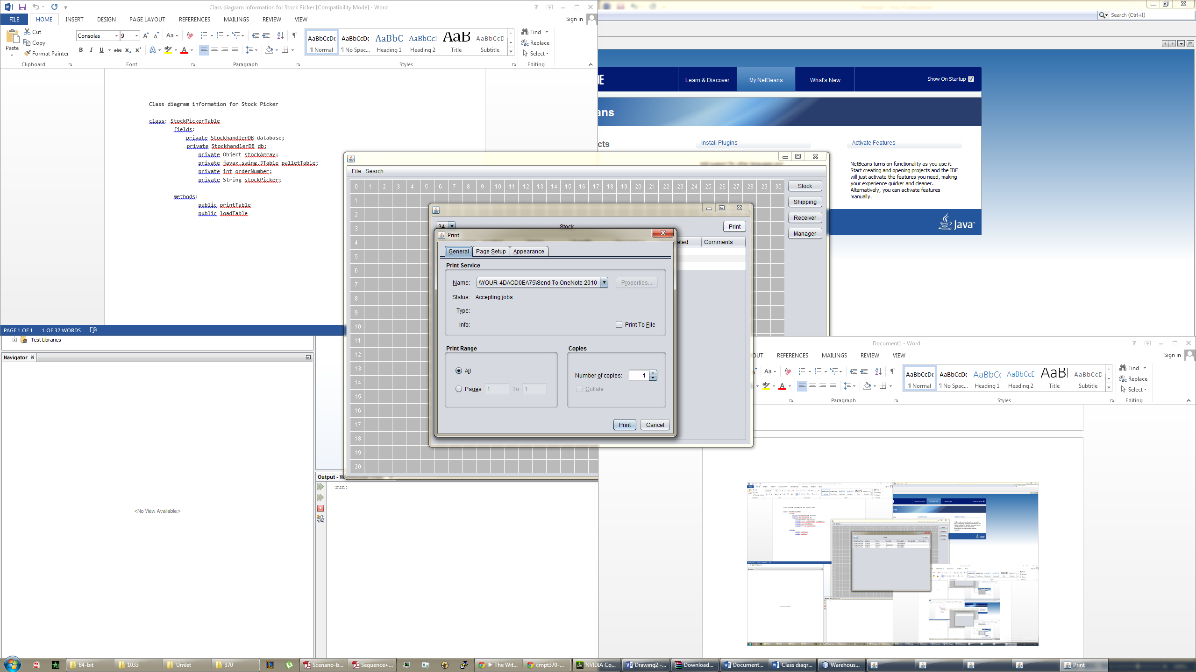

Congratulations you have now printed your order to do in the fastest possible route.